

ServiceNow Integration Manual

**Department: Professional Services**

**August 2019, Ver.1.0**

Table of Contents

Description 3

Contents 3

Requirements 7

Installation 7

Configuration 7

Samplers 7

Commands 8

KBA 9

Output 9

Reference Docs 11

Description

The Geneos integration with ServiceNow has the ability to automate Geneos alert messages into your ServiceNow environment. This integration also provides a view of your ServiceNow tickets under different statuses, and the ability to modify tickets from Geneos.

Contents

* Toolkit Samplers
  + *Incident-Open* - List of Tickets that are not closed or not solved
  + *Incident-OnHold* - List of Tickets that are "On Hold"
  + *Incident-InProgress* - List of tickets that are "InProgress"
  + *Change-New* - List of Change requests that are newly created
  + *Change-OnHold* - List of Change requests that are "On Hold"
  + *Change-Closed* - List of Change requests that are "InProgress"
* Commands
  + **Create Incident/Create Change** - This will create a corresponding Incident/Change Request ticket in ServiceNow and will pass the following Geneos parameters:
    - Gateway Name
    - Netprobe Name
    - Managed Entity Name
    - Sampler Name
    - Dataview Name
    - Rowname
    - Column
    - Value

Upon calling the command, you will be prompted to fill in the following fields:

1. Impact (1-High, 2-Medium, 3-Low)
2. Urgency (1-High, 2-Medium, 3-Low)
3. Notes for Description

NOTE: You can run the Create/Create Change command from any data cell

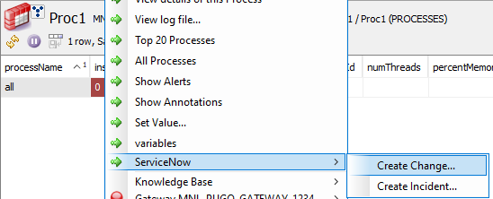

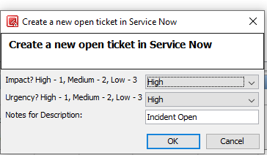

Sample Incident/Change request created from this command:

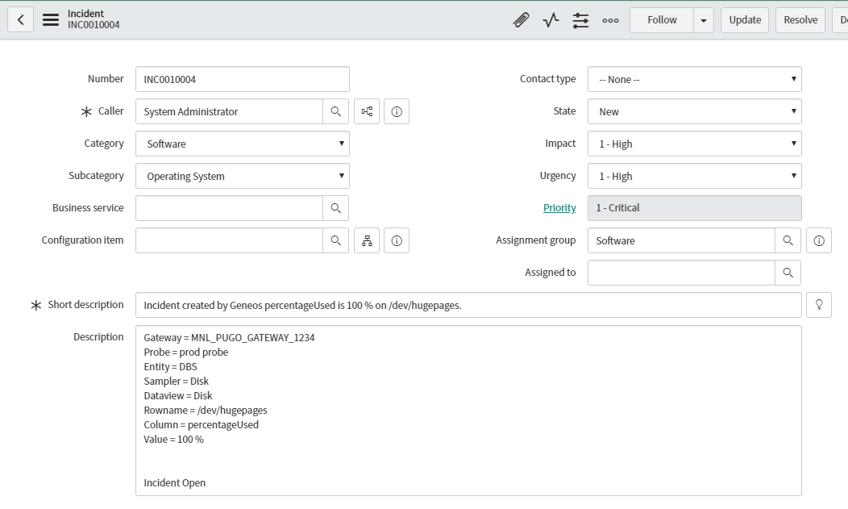

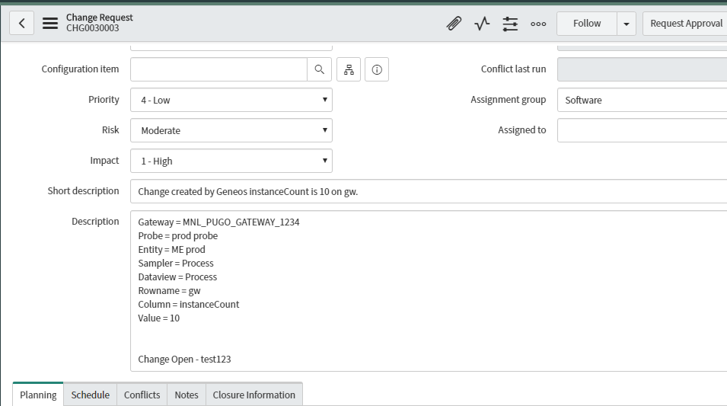

* + **Update Incident/Update Change** - This will update an existing Incident/Change Request ticket in ServiceNow.

Upon calling the command, you will be prompted to fill in the following fields:

1. Impact (1-High, 2-Medium, 3-Low)
2. Urgency (1-High, 2-Medium, 3-Low)
3. Notes for Description

Below is the corresponding output in the ticket/Change request:

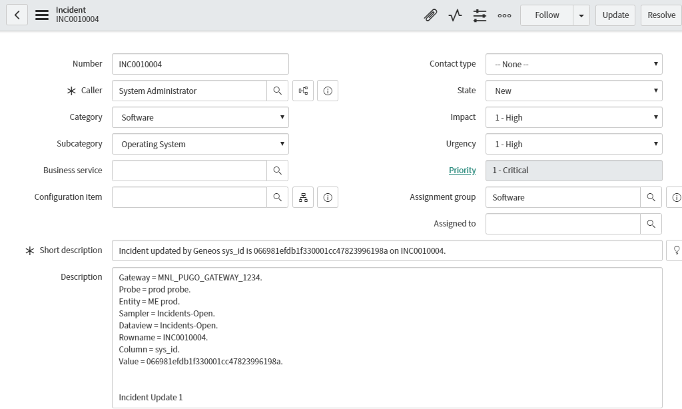

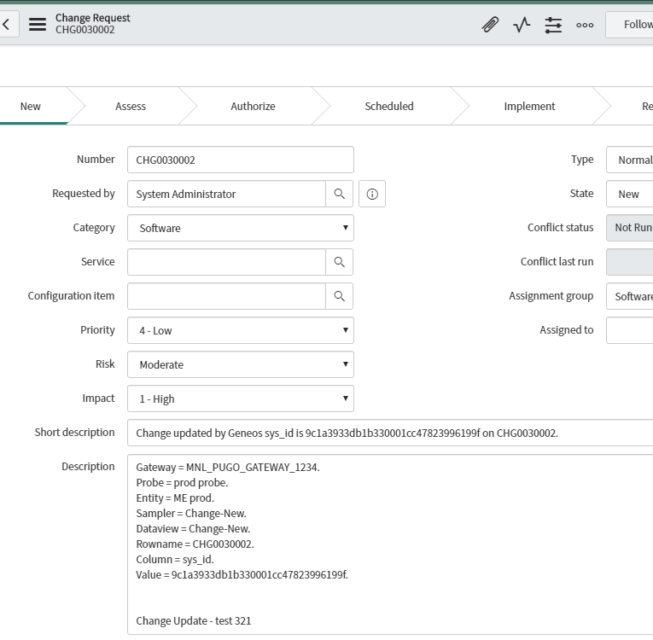

* + **Resolve Incident** - This will set the status of a corresponding Incident ticket in ServiceNow to “Resolved”.
  + **Close Incident** - This will set the status of a corresponding Incident ticket in ServiceNow to “Closed”.

Requirements

You must have python 3.5 or higher to install:

$ python -V

This script does depend on the requests and pysnow module pysnow:

$ pip install pysnow

There are instructions on the [web](https://pysnow.readthedocs.io/en/latest/general.html#installing) on how to do this.

Installation

1. Open up the Gateway Setup Editor.
2. In the Gateway Setup Editor, right click on the "Includes" folder, then add a new include.
3. Enter in the path to the ServiceNow Template and change the priority (to something other than 1).
4. Load the ServiceNow include file by clicking on the plus sign by the new file, and then clicking "Click to load...".
5. The template uses the following variables whose default values are defined under: servicenowMonitoring.xml -> Environments -> ServiceNow.
6. Download the Create_Query_Incidents.py script from the github page and place it in either your gateway or netprobe server. This script will be used/called for the commands.

Configuration

Samplers

For each of the toolkit samplers – ServiceNow Incidents and Change, you must configure the appropriate TableSpace name, username, password, and ServiceNow instance name. Below is an example of view of a configured toolkit. The variables are defined in the ServiceNow environment, which you need to fill out.

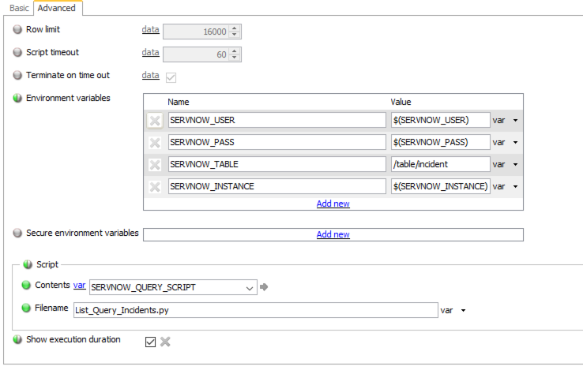

Commands

For the commands, call the Create_Query_Incidents.py script from either the gateway or netprobe:

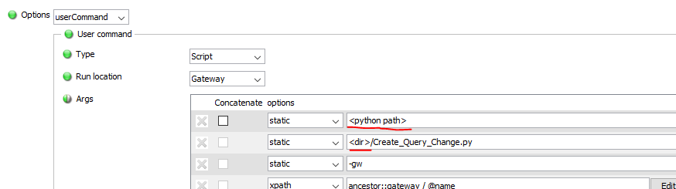

NOTE: Please modify the <python path> and <dir> accordingly

The same variables (as in the samplers) must be defined in the Commands:

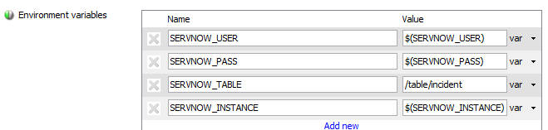

Specific to the *Create Incident* and *Create Change* commands, you need to input the details or define the variable in the Operating Environment. Note that these commands can be run from **any** cell, so it must be able to resolve to the corresponding variable.

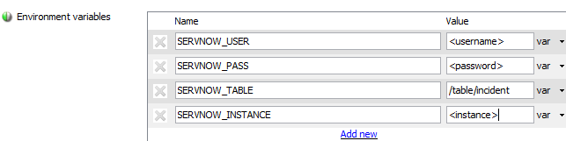

KBA

Simply input your instance name in the Knowledge Base URL Template for both Incident and Change Request Details Page:

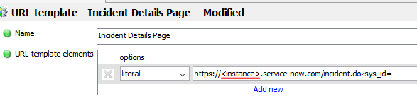

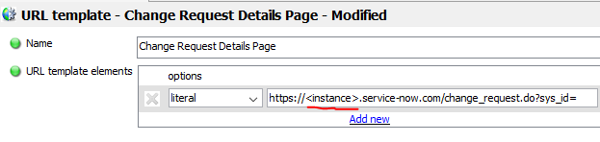

Output

There will 2 categories that are covered in this template: Incident and Change. For Incident category, there will be 3 statuses that will be reflected: Open, On Hold, and In Progress. Meanwhile, for the Change category, the 3 statuses are: New, On Hold, and Closed. Sample dataviews can be found below:

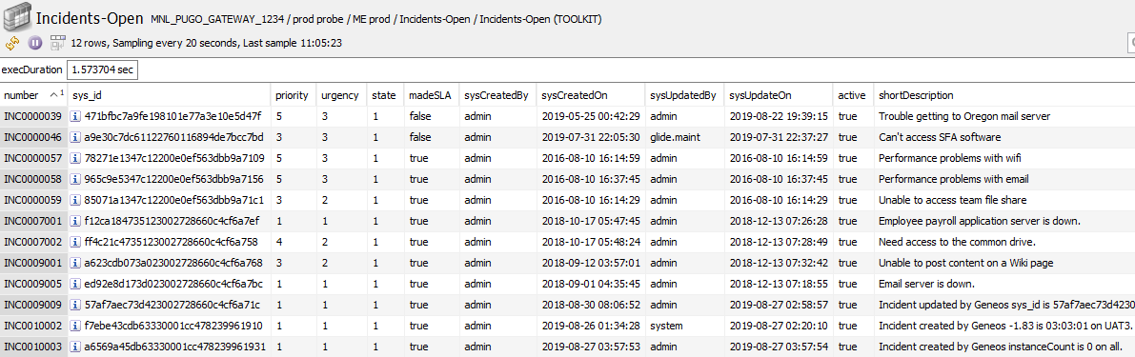

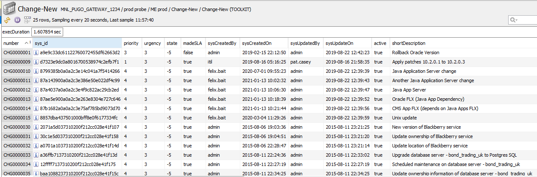

Right-clicking on the *sys_id* column on any of the dataviews, you should be able to choose the *Knowledge Base >> Service Now Incident/Change Request* link, which will redirect you to the actual ServiceNow page.

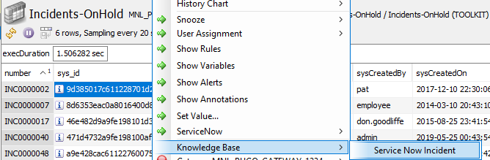

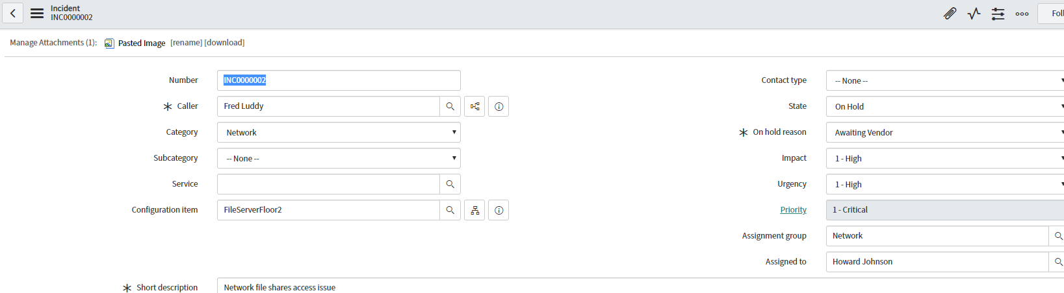

Reference Docs

<https://pysnow.readthedocs.io/en/latest/>

<https://docs.servicenow.com/bundle/newyork-it-service-management/page/product/change-management/task/state-model-activate-tasks.html>